Online Retail Sales Dashboard Report

# 1. Introduction

This Report involves creating a sales dashboard using Microsoft Excel based on a dataset of 500 online retail transactions. The dashboard aims to provide visual insights through charts and slicers, enabling users to interactively filter and analyse data.

# 2. Dataset Description

The dataset contains 500 rows and the following columns:  
  
- Order ID  
- Order Date  
- Customer Name  
- Country  
- Category  
- Product Name  
- Quantity  
- Unit Price  
- Total Sales  
- Payment Method  
  
It simulates real-world online sales records from multiple countries and includes multiple categories and payment methods.

# 3. Dashboard Overview

A dashboard is a visual display of key data points, often presented as charts, graphs, and tables, designed to provide a quick overview of a specific area or project. This dashboard was created using Excel and includes six different charts representing sales trends, product performance, and payment methods. It also includes slicers for dynamic filtering based on fields such as Category, Country, and Payment Method.

# 4. Chart Explanations

A chart is a visual representation of data that transforms numerical information into a graphical format, making it easier to understand patterns, trends, and comparisons. Charts are useful for analysing and communicating data, especially when dealing with large datasets. The Following charts which have been used:

## Chart 1: Total Sales by Category

Type: Column Chart  
Details: Category (X-axis), Total Sales (Y-axis), Slicer: Country

## Chart 2: Monthly Sales Trend

Type: Line Chart  
Details: Order Date by Month (X-axis), Total Sales (Y-axis), Slicer: Category

## Chart 3: Top 5 Products by Sales

Type: Bar Chart  
Details: Product Name (Y-axis), Total Sales (X-axis), Filtered Top 5, Slicer: Country

## Chart 4: Sales by Payment Method

Type: Pie Chart  
Details: Payment Method (Legend), Total Sales (Values), Slicer: Category

## Chart 5: Quantity Sold by Country

Type: Column Chart  
Details: Country (X-axis), Quantity (Y-axis), Slicer: Product Name

## Chart 6: Sales by Country and Category

Type: Clustered Column Chart  
Details: Country (X-axis), Total Sales (Y-axis), Legend: Category, Slicer: Payment Method

# 5. Slicer Functionality

Slicers were added to make the dashboard interactive. The user can filter charts by Category, Country, and Payment Method. When a slicer value is selected, all connected charts update dynamically to show only the filtered data.

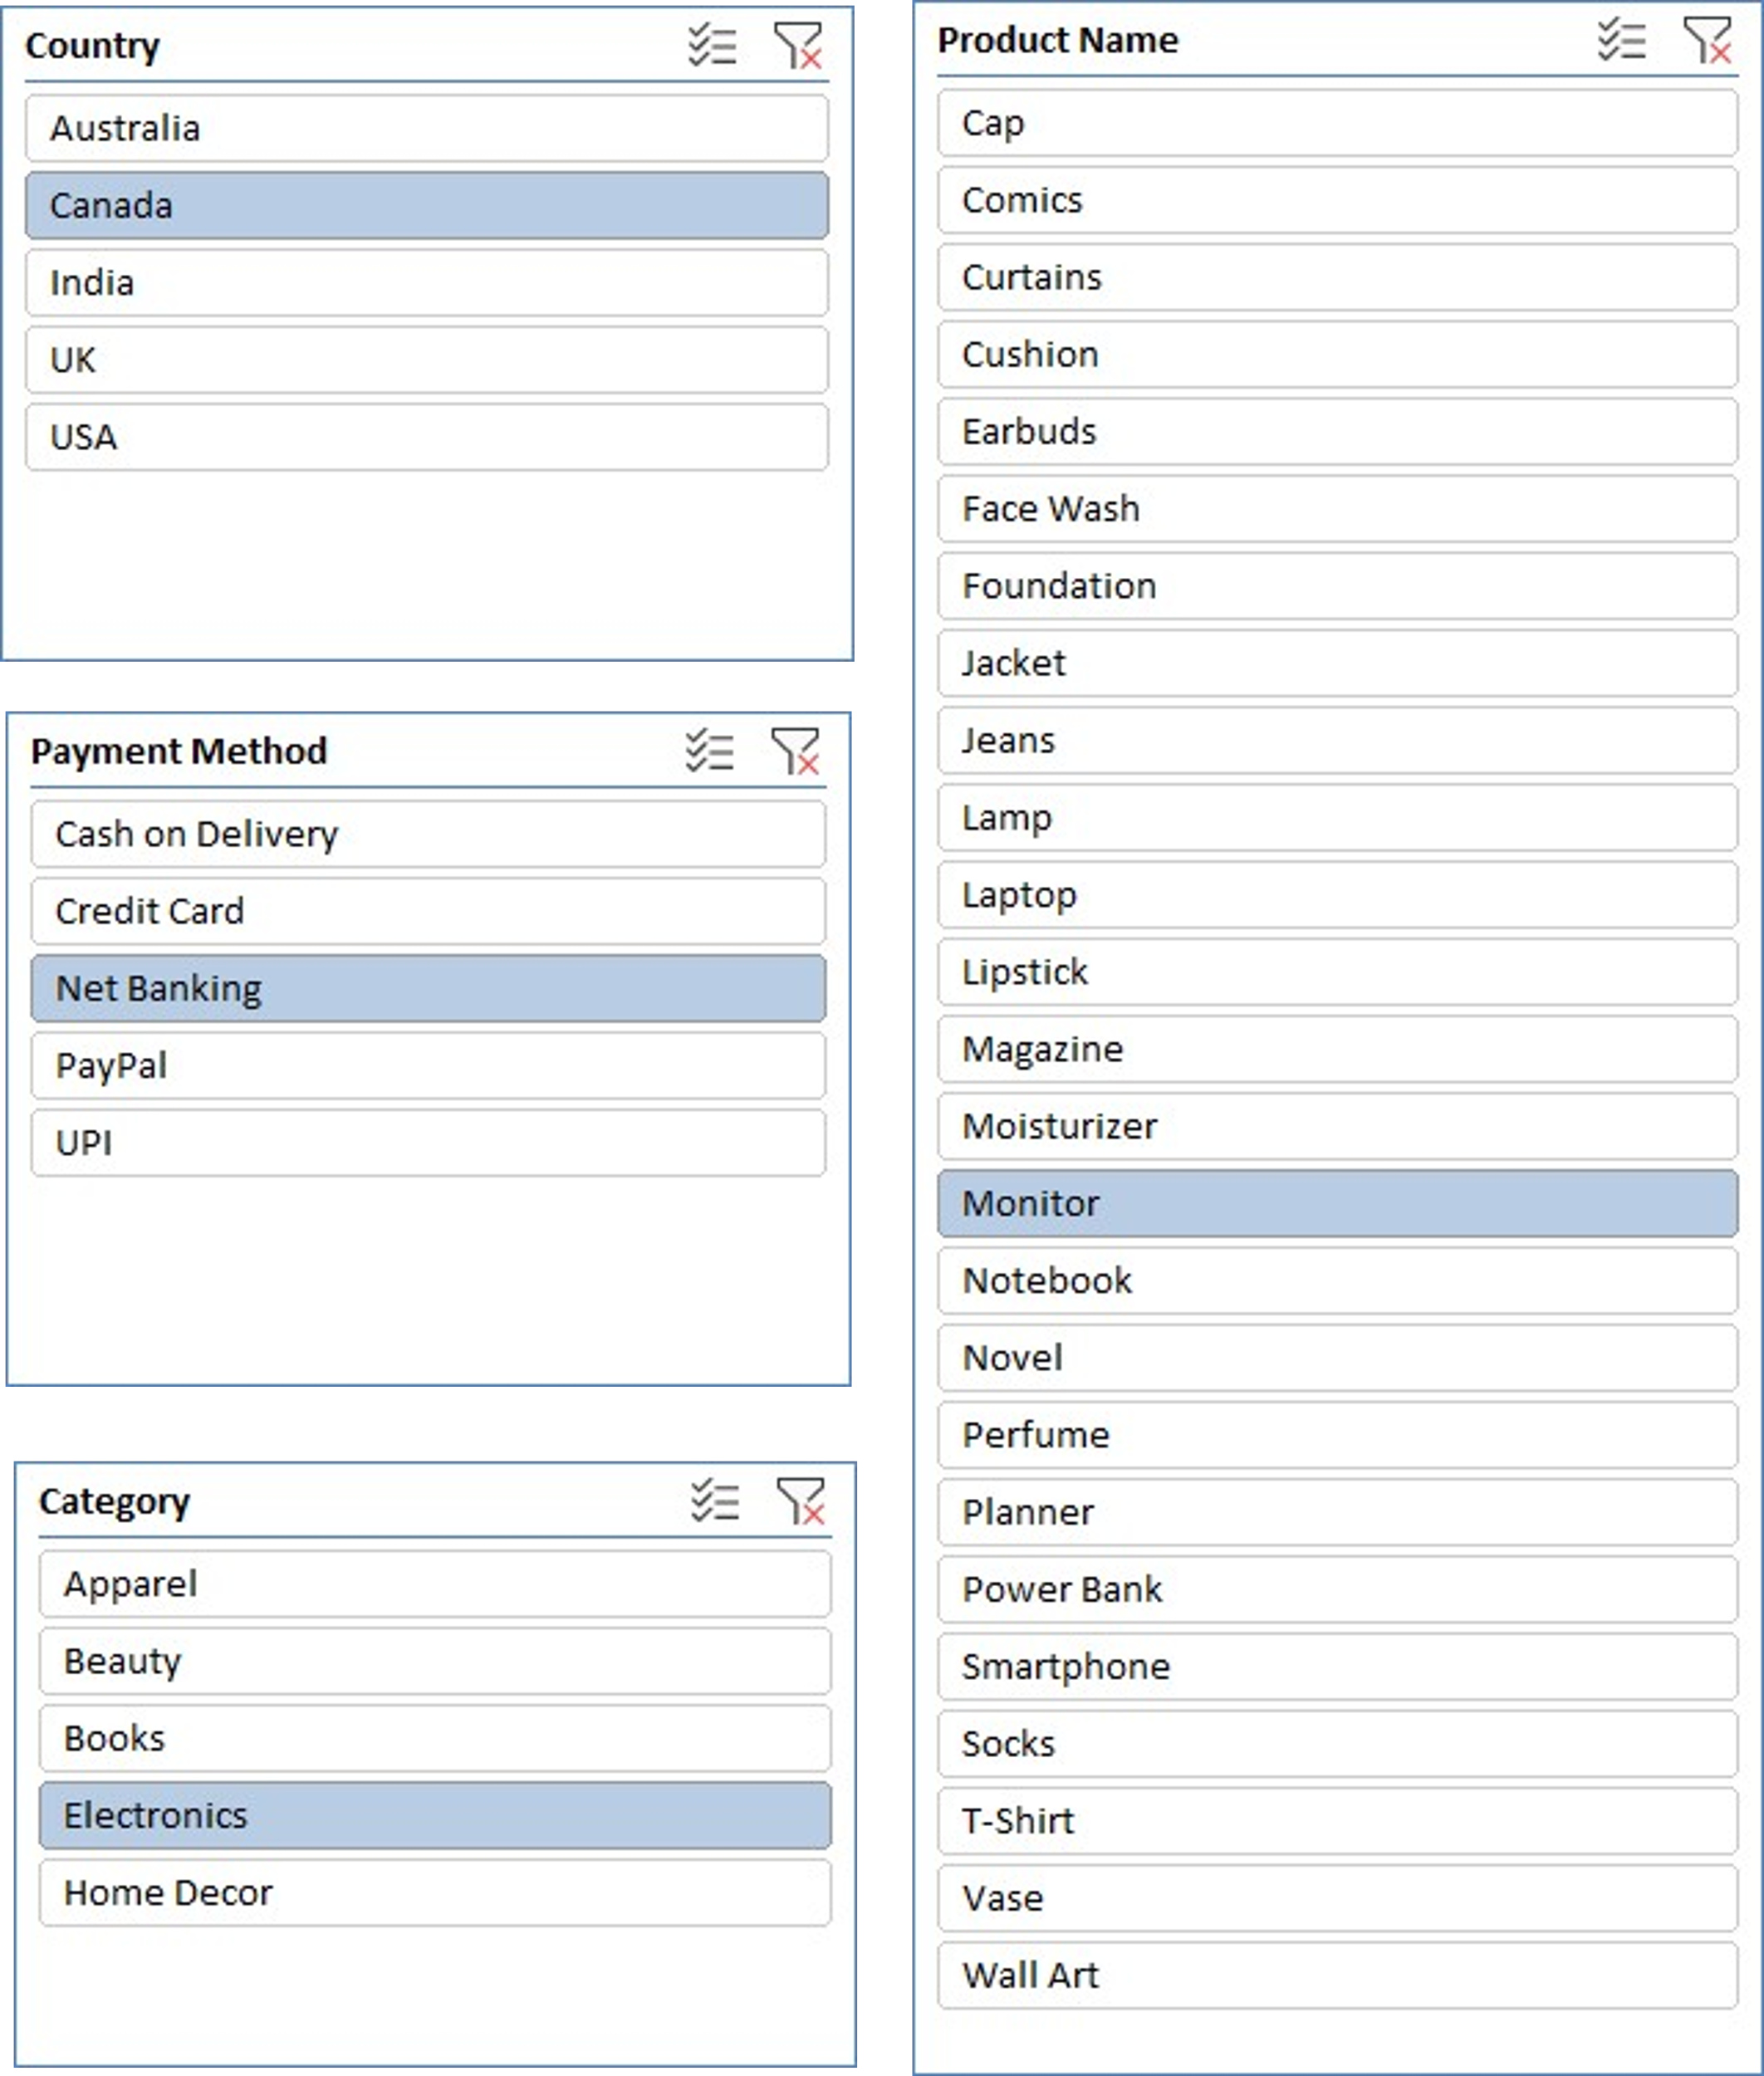

# 6. Observations / Insights

**Chart 1 Observation: Total Sales by Category (Country wise)**

|  |  |  |  |  |  |  |
| --- | --- | --- | --- | --- | --- | --- |
| **Sum of Total Sales** | **Column Labels** |  |  |  |  |  |
| **Row Labels** | **Apparel** | **Beauty** | **Books** | **Electronics** | **Home Decor** | **Grand Total** |
| Australia | 17518.44 | 31751.64 | 21786.43 | 34717.67 | 21703.11 | 127477.29 |
| Canada | 26988.36 | 18296.09 | 24730.62 | 29298.72 | 31563.58 | 130877.37 |
| India | 28208.34 | 33970.22 | 20172.13 | 29393.8 | 18679.27 | 130423.76 |
| UK | 28088.45 | 30034.27 | 25678.04 | 23455.41 | 20037.87 | 127294.04 |
| USA | 39335.76 | 26421.92 | 20093.29 | 32411.67 | 20603.9 | 138866.54 |
| **Grand Total** | **140139.35** | **140474.14** | **112460.51** | **149277.27** | **112587.73** | **654939** |

*The chart analyzes total sales across five product categories segmented by country.* ***Electronics*** *emerges as the highest grossing category with* ***₹149,277.27*** *in total sales, driven largely by strong figures from Australia (₹34,717.67) and the USA (₹32,411.67).* ***Beauty*** *is a close second with ₹140,474.14, with India (₹33,970.22) and Australia (₹31,751.64) contributing the most.* ***Apparel*** *saw its peak sales in the USA at ₹39,335.76, leading to a cumulative total of ₹140,139.35. While* ***Books*** *(₹112,460.51) and* ***Home Decor*** *(₹112,587.73) had relatively lower sales, both categories maintained consistent performance across all regions. Overall, the USA is the top-performing country in total sales, followed by India and Canada.*

**Chart 2 Observation: Monthly Sales Trend (Category wise)**

|  |  |  |  |  |  |  |
| --- | --- | --- | --- | --- | --- | --- |
| **Sum of Total Sales** | **Column Labels** |  |  |  |  |  |
| **Row Labels** | **Apparel** | **Beauty** | **Books** | **Electronics** | **Home Decor** | **Grand Total** |
| Jan | 12957.62 | 10035.6 | 15241.77 | 12106.8 | 12974.56 | 63316.35 |
| Feb | 22091.6 | 26040.33 | 7223.49 | 29003.08 | 3641.94 | 88000.44 |
| Mar | 15915.41 | 11971.23 | 21524.32 | 23708.87 | 11693.18 | 84813.01 |
| Apr | 14717.54 | 20819.12 | 17257.01 | 16609.09 | 23998.39 | 93401.15 |
| May | 33916.71 | 26233.89 | 21643.3 | 16946.26 | 19583.07 | 118323.23 |
| Jun | 17216.06 | 39838.76 | 21456.87 | 41494.42 | 29921.31 | 149927.42 |
| Jul | 23324.41 | 5535.21 | 8113.75 | 9408.75 | 10775.28 | 57157.4 |
| **Grand Total** | **140139.35** | **140474.14** | **112460.51** | **149277.27** | **112587.73** | **654939** |

*The monthly sales trend chart highlights a* ***progressive increase in sales from January to June****, followed by a* ***noticeable decline in July****. The* ***peak sales occurred in June****, reaching a total of* ***₹1,49,927.42****, with* ***Electronics (₹41,494.42)*** *and* ***Beauty (₹39,838.76)*** *making the highest contributions.* ***May*** *also recorded strong performance with* ***₹1,18,323.23*** *in total sales, largely supported by the* ***Apparel*** *and* ***Books*** *categories. In contrast,* ***July marked the lowest point****, with sales dropping to* ***₹57,157.40****, signaling a significant post-surge decline. Overall, the trend indicates a* ***high-performing Q2****, especially in* ***May and June****, suggesting seasonal peaks or promotional impacts during this period.*

**Chart 3 Observation: Product-wise Sales Distribution (All Products)**

|  |  |  |  |  |  |  |
| --- | --- | --- | --- | --- | --- | --- |
| **Sum of Total Sales** | **Column Labels** |  |  |  |  |  |
| **Row Labels** | **Australia** | **Canada** | **India** | **UK** | **USA** | **Grand Total** |
| Cap | 2355.39 | 8284.31 | 9131.29 | 7095.89 | 2285.9 | 29152.78 |
| Comics | 7350.72 | 2491.58 | 2765.8 | 2473.08 | 4293.75 | 19374.93 |
| Curtains | 4556.99 | 5297.12 | 4926.9 | 474.29 | 3854.27 | 19109.57 |
| Cushion | 8779.09 | 9913.48 | 5197.51 | 3490.71 | 3851.1 | 31231.89 |
| Earbuds | 1522.82 | 13722.84 | 6795.75 | 1416.32 | 6136.69 | 29594.42 |
| Face Wash | 9190.22 | 1677.67 | 3547.84 | 6693.89 | 2042.37 | 23151.99 |
| Foundation | 2827.81 | 6082.89 | 3629.92 | 14131.06 | 5179.21 | 31850.89 |
| Jacket | 5530.78 | 7820.61 | 4211.22 | 7640.88 | 11965.43 | 37168.92 |
| Jeans | 5529.88 | 314.1 | 5173.15 | 5931.92 | 6689.4 | 23638.45 |
| Lamp | 2043.55 | 3855.04 | 6308.25 | 7332.47 | 834.8 | 20374.11 |
| Laptop | 5013.55 | 1836.27 | 6777.82 | 7529.95 | 2780.83 | 23938.42 |
| Lipstick | 6198.89 | 6650.18 | 7005.48 | 2915.45 | 7760.31 | 30530.31 |
| Magazine | 3612.12 | 6634.47 | 1638.18 | 13614.12 | 573 | 26071.89 |
| Moisturizer | 9446.9 | 2587 | 12969.31 | 235.7 | 5088.98 | 30327.89 |
| Monitor | 13607.61 | 3849.6 | 3184.99 | 3140.64 | 11356.99 | 35139.83 |
| Notebook | 1783.34 | 9748.39 | 2699.08 | 2273.92 | 4448.18 | 20952.91 |
| Novel | 4741.44 | 5856.18 | 7832.88 | 6155.87 | 5459.72 | 30046.09 |
| Perfume | 4087.82 | 1298.35 | 6817.67 | 6058.17 | 6351.05 | 24613.06 |
| Planner | 4298.81 | 4332.44 | 5236.19 | 1161.05 | 5318.64 | 16014.69 |
| Power Bank | 4530.04 | 4420.47 | 4819.25 | 5148.3 | 7219.62 | 26137.68 |
| Smartphone | 10043.65 | 5469.54 | 7815.99 | 6220.2 | 4917.54 | 34466.92 |
| Socks | 835.19 | 3733.52 | 9289.49 | 1755.28 | 18291.41 | 33904.89 |
| T-Shirt | 3267.2 | 6835.82 | 403.19 | 5664.48 | 103.62 | 16274.31 |
| Vase | 5328.61 | 2032.76 | 285.42 | 5850.87 | 9102.37 | 22600.03 |
| Wall Art | 994.87 | 10465.18 | 1961.19 | 2889.53 | 2961.36 | 19272.13 |
| **Grand Total** | **127477.29** | **130877.37** | **130423.76** | **127294.04** | **138866.54** | **654939** |

* *The bar chart illustrating sales across all products highlights* ***significant diversity in customer preferences and purchase behaviour****.*
* ***Jacket (₹37,168.92)*** *emerges as the* ***top-selling product overall****, reflecting strong demand across both fashion and utility.*
* ***Monitor (₹35,139.99)*** *and* ***Smartphone (₹34,466.68)*** *also show* ***consistently high sales****, confirming that* ***electronics are a major revenue driver****.*
* ***Socks (₹33,904.49)*** *ranks surprisingly high, indicating it may be a high-volume, frequently purchased item.*
* *Other notable performers include* ***Moisturizer (₹30,327.89)****,* ***Notebook (₹20,952.91)****, and* ***Lipstick (₹30,530.31)****, demonstrating strong interest in beauty and personal care.*
* *On the lower end:*
* ***Items like Cap (₹29,152.78)****,* ***Lamp (₹20,374.11)****, and* ***Curtains (₹19,109.57)*** *showed comparatively* ***lower total sales****, possibly due to lower frequency of purchase or limited market appeal.*
* ***Wall Art (₹19,272.13)*** *and* ***Vase (₹22,600.03)*** *represent niche segments with modest but steady sales.*

*So, by considering all of it we could say that the chart highlights that consumer spending is well-distributed across categories,* ***but electronics and fashion accessories dominate the sales landscape****.*

**Chart 4 Observation: Sales by Payment Method (Category wise)**

|  |  |  |  |  |  |  |
| --- | --- | --- | --- | --- | --- | --- |
| **Sum of Total Sales** | **Column Labels** |  |  |  |  |  |
| **Row Labels** | **Apparel** | **Beauty** | **Books** | **Electronics** | **Home Decor** | **Grand Total** |
| Cash on Delivery | 32044.92 | 35916.79 | 14295.31 | 27008.33 | 15298.08 | 124563.43 |
| Credit Card | 29485.95 | 26926.97 | 26817.21 | 25951.9 | 13921.14 | 123103.17 |
| Net Banking | 33227.63 | 21062.89 | 30730.55 | 37882.62 | 20376.49 | 143280.18 |
| PayPal | 25828.37 | 21788.73 | 18161.19 | 30677.9 | 36096.22 | 132552.41 |
| UPI | 19552.48 | 34778.76 | 22456.25 | 27756.52 | 26895.8 | 131439.81 |
| **Grand Total** | **140139.35** | **140474.14** | **112460.51** | **149277.27** | **112587.73** | **654939** |

*The pie chart illustrates the distribution of total sales across various payment methods.* ***Net Banking*** *ranks* ***highest****, contributing* ***₹1,43,280.18****, making it the* ***most preferred mode of payment*** *among customers. This suggests that users likely trust bank transactions for online retail purchases.*

*Following closely,* ***PayPal*** *accounts for* ***₹1,32,552.41****, indicating strong adoption, possibly due to its user-friendly interface and international acceptance.* ***UPI****, with* ***₹1,31,439.81****, also shows widespread usage, especially as a fast and convenient digital payment method in domestic markets.*

***Cash on Delivery (₹1,24,563.43)*** *and* ***Credit Card (₹1,23,103.17)*** *rank lower than expected, despite their traditional popularity. This trend might reflect a shift toward digital-first payment ecosystems or customer preference for flexible and no-interest options like UPI or wallets.*

*🔹* ***Highlight****: The chart suggests a strong* ***digital payment adoption trend****, with* ***Net Banking, PayPal, and UPI*** *jointly contributing nearly* ***63% of the total revenue****, underscoring the need for continued support and optimization of digital checkout experiences.*

**Chart 5 Observation: Quantity Sold by Country (Product wise)**

|  |  |  |  |  |  |  |  |  |  |  |
| --- | --- | --- | --- | --- | --- | --- | --- | --- | --- | --- |
| **Sum of Quantity** | **Column Labels** |  |  |  |  |  |  |  |  |  |
| **Row Labels** | **Cap** | **Comics** | **Curtains** | **Cushion** | **Earbuds** | **Face Wash** | **Foundation** | **Jacket** | **Jeans** | **More...** |
| Australia | 6 | 29 | 26 | 38 | 11 | 45 | 8 | 23 | 18 | - |
| Canada | 38 | 14 | 25 | 33 | 49 | 21 | 27 | 37 | 9 | - |
| India | 38 | 14 | 15 | 20 | 31 | 25 | 23 | 14 | 21 | - |
| UK | 37 | 16 | 5 | 24 | 7 | 23 | 52 | 20 | 30 | - |
| USA | 16 | 18 | 11 | 15 | 26 | 17 | 18 | 43 | 27 | - |
| **Grand Total** | **135** | **91** | **82** | **130** | **124** | **131** | **128** | **137** | **105** | **-** |

*This column chart compares the* ***total number of products sold across five countries****.*

* ***Canada*** *ranks* ***highest*** *with a total of* ***566 units sold****, showing* ***strong product engagement****. This could be due to a balanced demand across various product types, as seen in their consistent mid-to-high quantities across the table.*
* ***Australia*** *and* ***India*** *follow closely with* ***541*** *and* ***521*** *units sold respectively. These countries show particularly high sales in categories like* ***Earbuds****,* ***Face Wash****, and* ***Moisturizer****, hinting at* ***tech-savvy and grooming-conscious audiences****.*
* *The* ***USA****, despite having the highest sales revenue earlier, sold* ***516 units****, indicating that American customers might prefer* ***higher-value products*** *with lower quantities.*
* ***The UK*** *has the* ***lowest quantity sold*** *at* ***493 units****, although still very competitive. Notably, the UK shows strong numbers in* ***Jackets (52 units)*** *and* ***Lamps (31 units)****, suggesting seasonal or lifestyle-driven demand.*

*🔹* ***Highlight****:* ***Canada leads in total units sold****, whereas* ***the USA focuses on fewer but likely higher-priced items****. This shows varying* ***consumer behaviour and purchasing patterns by region****.*

**Chart 6 Observation: Sales by Country and Category (Payment Method wise)**

|  |  |  |  |  |  |  |
| --- | --- | --- | --- | --- | --- | --- |
| **Sum of Total Sales** | **Column Labels** |  |  |  |  |  |
| **Row Labels** | **Cash on Delivery** | **Credit Card** | **Net Banking** | **PayPal** | **UPI** | **Grand Total** |
| **Australia** | **19601.56** | **18990.43** | **33683.25** | **33154.92** | **22047.13** | **127477.29** |
| Apparel | 2335.15 | 5344.6 | 1388.34 | 4172.91 | 4277.44 | 17518.44 |
| Beauty | 2077.9 | 3228.14 | 6576.84 | 10735.74 | 9133.02 | 31751.64 |
| Books | 4334.1 | 5568.24 | 3862.16 | 6391.77 | 1630.16 | 21786.43 |
| Electronics | 7130.35 | 2656.04 | 15695.7 | 3211.23 | 6024.35 | 34717.67 |
| Home Decor | 3724.06 | 2193.41 | 6160.21 | 8643.27 | 982.16 | 21703.11 |
| **Canada** | **25035.31** | **17783.33** | **29027.77** | **27762.53** | **31268.43** | **130877.37** |
| Apparel | 9256.89 | 4029.85 | 7063.77 | 6073.97 | 563.88 | 26988.36 |
| Beauty | 6508.98 | 5765.06 |  | 4423.87 | 1598.18 | 18296.09 |
| Books | 2372.33 | 503.1 | 10138.61 | 2737.62 | 8978.96 | 24730.62 |
| Electronics | 5352.23 | 6558.22 | 7322.85 | 1849.77 | 8215.65 | 29298.72 |
| Home Decor | 1544.88 | 927.1 | 4502.54 | 12677.3 | 11911.76 | 31563.58 |
| **India** | **23253.73** | **32624.82** | **20505.5** | **24564.71** | **29475** | **130423.76** |
| Apparel | 3901.52 | 15067.29 | 4172.5 | 3881.48 | 1185.55 | 28208.34 |
| Beauty | 3188.01 | 2933.14 | 5109.22 | 3843.45 | 18896.4 | 33970.22 |
| Books | 2949.92 | 6049.6 | 5545.8 | 4127.67 | 1499.14 | 20172.13 |
| Electronics | 10251.49 | 3785.41 | 4150.94 | 7122.43 | 4083.53 | 29393.8 |
| Home Decor | 2962.79 | 4789.38 | 1527.04 | 5589.68 | 3810.38 | 18679.27 |
| **UK** | **28170.47** | **30432.49** | **29171.39** | **17537.82** | **21981.87** | **127294.04** |
| Apparel | 10567.8 | 3257.19 | 3700.78 | 4605.8 | 5956.88 | 28088.45 |
| Beauty | 8188.87 | 8627.89 | 9193.13 | 1716.38 | 2308 | 30034.27 |
| Books | 3165.81 | 9013.4 | 6083.62 | 2842.95 | 4572.26 | 25678.04 |
| Electronics | 2806 | 4782.9 | 7755.37 | 5076.9 | 3034.24 | 23455.41 |
| Home Decor | 3441.99 | 4751.11 | 2438.49 | 3295.79 | 6110.49 | 20037.87 |
| **USA** | **28502.36** | **23272.1** | **30892.27** | **29532.43** | **26667.38** | **138866.54** |
| Apparel | 5983.56 | 1787.02 | 16902.24 | 7094.21 | 7568.73 | 39335.76 |
| Beauty | 15953.03 | 6372.74 | 183.7 | 1069.29 | 2843.16 | 26421.92 |
| Books | 1473.15 | 5682.87 | 5100.36 | 2061.18 | 5775.73 | 20093.29 |
| Electronics | 1468.26 | 8169.33 | 2957.76 | 13417.57 | 6398.75 | 32411.67 |
| Home Decor | 3624.36 | 1260.14 | 5748.21 | 5890.18 | 4081.01 | 20603.9 |
| **Grand Total** | **124563.43** | **123103.17** | **143280.18** | **132552.41** | **131439.81** | **654939** |

*This clustered column chart breaks down total sales across five countries and five product categories, filtered by selected* ***Payment Method*** *via slicer.*

***Key Highlights:***

*🔹* ***USA*** *leads in total sales when* ***PayPal*** *is selected, with* ***Electronics (₹13,417.57)*** *being the most dominant category under this method.*

*🔹* ***India****'s* ***Home Decor*** *category performs well under* ***Net Banking (₹7,122.43)****, reflecting high-value purchases made via digital payments.*

*🔹 In* ***Australia****, the* ***Beauty category*** *is significantly strong with* ***₹10,735.74*** *sales via* ***PayPal****, indicating preference for online purchases of personal care items.*

*🔹* ***Canada*** *shows the* ***highest Home Decor sales (₹12,677.3)****, largely boosted by* ***UPI payments****, signalling modern payment adoption for luxury categories.*

*🔹* ***UK****'s most consistent performer is* ***Electronics****, with decent figures spread across payment modes, peaking under* ***Net Banking and UPI****.*

***Notable Trends:***

*📌* ***Net Banking*** *emerges as the top-grossing method overall (****₹1,43,280.18****), especially impactful in India and the UK.*

*📌* ***UPI and PayPal*** *are also widely used across multiple countries, highlighting the popularity of modern digital wallets.*

*📌* ***Cash on Delivery****, while still present, is overshadowed by digital alternatives in higher sales categories.*

# 7. Conclusion

The dashboard provides a comprehensive analysis of global retail sales performance across various dimensions of product categories, countries, time trends, payment methods, and customer preferences. From the visual insights, it's evident that **Electronics** and **Beauty** are the highest revenue-generating categories, while countries like **USA** and **India** consistently lead in overall sales. The **preferred payment methods vary by region**, with **Net Banking and UPI** dominating in India and **PayPal** showing strong usage in the USA and Australia. Seasonal spikes, particularly in **May and June**, indicate potential promotional or festive periods that significantly boost sales. This dashboard not only offers a dynamic view through slicers for deeper exploration but also supports data-driven decision-making for targeted marketing, inventory planning, and customer engagement strategies across global markets.